**Steps to filter out the logcat output of a specific app in Android Studio**

1. Ensure that the android phone is rooted.
2. Install the mobile app (Eg. SoloLearn) under testing on the rooted android phone.
3. Connect the phone via USB to the desktop and enable USB debugging under Developer Options in the phone.
4. Launch the Android Studio on the desktop
5. When prompted, enable the check box “Always allow from this computer” on the phone to allow USB debugging from the desktop.
6. Launch the app (SoloLearn)
7. Login to the phone using “adb shell” command using Android SDK platform tools on your desktop.
8. Type the below command by passing the package name of the app to check the process ID (PID) of the SoloLearn app.

shell@m0:/ $ ps | grep com.sololearn

1. From the output note down the PID (first column value) of the app

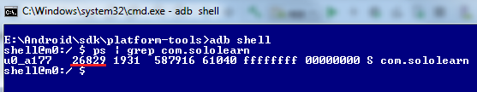

1. In the Android Studio, open Logcat and click on Edit Filter Configuration which is on the right side of the studio

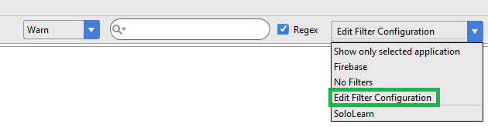

1. Provide a Filter name (Eg. SoloLearn) Type the PID, Set the Log Level and click Ok

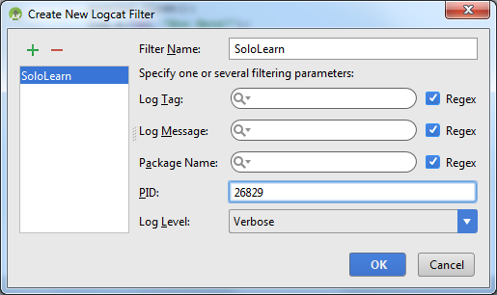

1. Now the logcat will start showing only the logs pertaining to SoloLearn App.
2. Now perform required operations on the app and simultaneously check the logs if any sensitive information is being written on the logs. This way of analyzing the log is Dynamic Analysis.